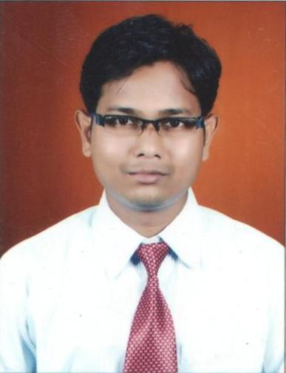
RESUME

SANGHDEEP N. GHARDE
AT. Rawanwadi, Gondia.
Mob.No: 08007930399
E-Mail: sanghdeep.gharde@gmail.com

CAREER OBJECTIVE

To make a positive impact in my field of activity, leading organization and personal growth by creative application of my value based conviction,
job skills & being a member of the winning team.

PROFESSIONAL QUALIFICATION
*BACHELOR IN PHARMACY from MANOHARBHAI PATEL INSTITUTE OF PHARMACY, GONDIA [M.H] UNDER THE RASHTRASANTTUKDOJIMAHARAJNAGPURUNIVERSITY.
*DIPLOMA IN PHARMACY from SHRI LAXMAN RAO MANKAR INSTITUTE OF PHARMACY,AMGAON[M.H.] UNDER THE MAHARASTRA STATE BOARD OF TECHNICAL EDUCATION in the year 2007.
SSC | 65% | BHOPAL 2002
HSC | 67% | BHOPAL 2005
D.PHARMACY-I | 75.45% | MSBTE 2006
D.PHARMACY-II | 70.30% | MSBTE 2007
B.PHARMACY-I | 58.30% | NAGPUR 2010
B.PHARMACY-II | 57.85% | NAGPUR 2011
B.PHARMACY-III | 57.32% | NAGPUR 2013
B.PHARMACY FINAL | A waiting result 2014 | NAGPUR 2014

EDUCATIONAL QUALIFICATION:

*SSC IN BIO From H.S.S. HIGH SCHOOL MALANJKHAND [M.P.] under the BHOPAL BOARD in the year 2002.
*HSC IN BIOLOGY From H.S.S. HIGH SCHOOL MALANJKHAND [M.P.] under the BHOPAL BOARD in the year 2005.

ACHIEVEMENTS:
*as a medical representative in megha health care at gondia headquater.
*pharmacist at wockhardth heart hospital Nagpur
*pharmacist at naticon laboratories pvt.ltd.nagpur.
*one year experience as a pharmacist in multy speciality hospital chandrapur.

*six months experience for industrial training in unijulex laboratories
limited,Nagpur.
*Participated in national social service program.

NATURE OF WORK:
*dispensing,handling,purchasing.
TECHNICAL QUALIFICATIONS:
MSCIT with 74%

STRENGTH:

*Good at analysis and synthesis of event.
*Good at taking initiatives and to lead the team.

PERSONAL SKILLS:

Good listener, Willingness to learn,believe strongly in teamwork and smart.

PERSONAL DETAILS:

Father's Name : Shri Nandkishore Gharde
Mother's Name : Smt. Indirabai Gharde
Date of Birth : 25 Oct 1986
Permanent Address : At. Po.Rawanwadi,Dist.Tah.Gondia441614
[MAHARASHTRA]
Contact no. : 08007930399
Languages Known : Marathi,Hindi & English
Hobbies : News paper reading, driving bike, listening
Songs.

I hereby declare that the above information is true to the best of my knowledge.

Date : 18/07/2016

Place : GONDIA(MAHARASHTRA)

Signature:

SANGHDEEP N. GHARDE

